# PAKISTAN INSTITUTE OF ENGINEERING AND APPLIED SCIENCES

**COMPUTER FUNDAMENTALS AND PROGRAMMING**

# Fall 2020

Assignment No. 03

Name: Umar Shifaqat

Department: DPAM

Roll No. BS-20-GB-100864

Date: 14 October, 2020

Report: 03

**Task 1**

**Write a program that performs all compound assignment operations on an integer.**

**INPUT**

#include<stdio.h>

int main()

{

int number=15;

printf("The value of integer is %d\n",number);

number+=5;

printf("The value of integer is %d\n",number);

number-=10;

printf("The value of integer is %d\n",number);

number*=9;

printf("The value of integer is %d\n",number);

number/=7;

printf("The value of integer is %d\n",number);

number%=8;

printf("The value of integer is %d",number);

getchar();

return 0;

}

The screenshot of the above program is:

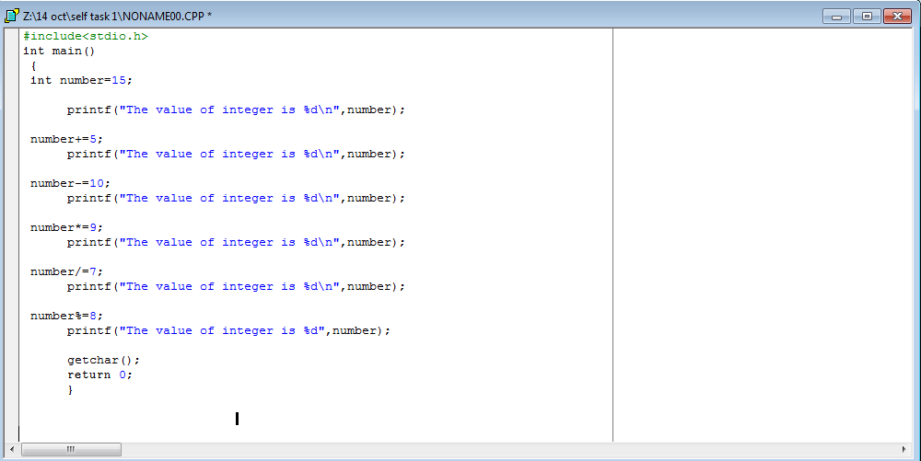

The screenshot of the .exe file of the above program is:

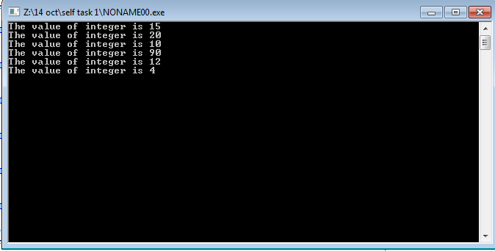

**Task 2**

**Write a program that performs all above mentioned trigonometric operations.**

**INPUT**

#include<stdio.h>

#include<math.h>

#define PI 3.14

int main()

{

float r,x,y,slope,theeta;

r=10;

theeta=20; //theeta in degree

theeta*=(PI/180); //theeta in rad

x=r*cos(theeta);

printf("The value of theeta in radian is %f\n\n",theeta);

printf("The value of x-component calculated from theeta is %f\n\n",x);

y=r*sin(theeta);

printf("The value of y-component calculated from theeta is %f\n\n",y);

slope=tan(theeta);

printf("The value of slope calculated from theeta is %f\n\n",slope);

theeta=acos(x/r);

printf("The value of theeta calculated from x-component is %f\n\n",theeta);

theeta=asin(y/r);

printf("The value of theeta calculated from y-component is %f\n\n",theeta);

theeta=atan(slope);

printf("The value of theeta calculated from slope is %f\n\n",theeta);

theeta=atan2(y,x);

printf("The value of theeta calculated from x,y - components is %f",theeta);

getchar();

return 0;

}

The screenshot of the above program is:

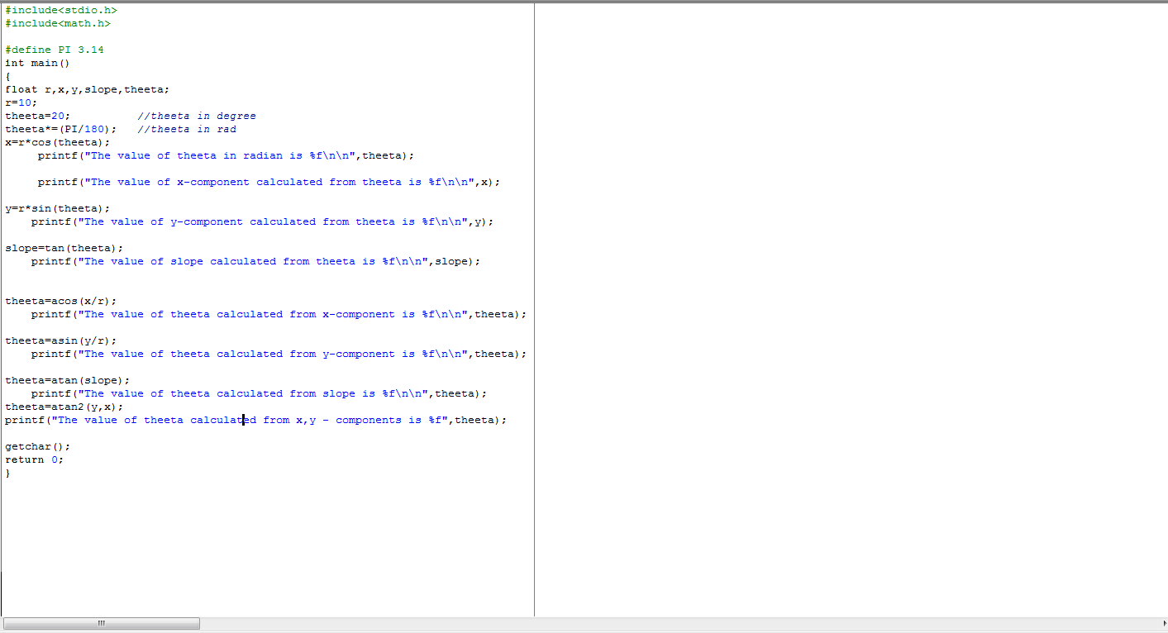

The screenshot of the .exe file of the above program is:

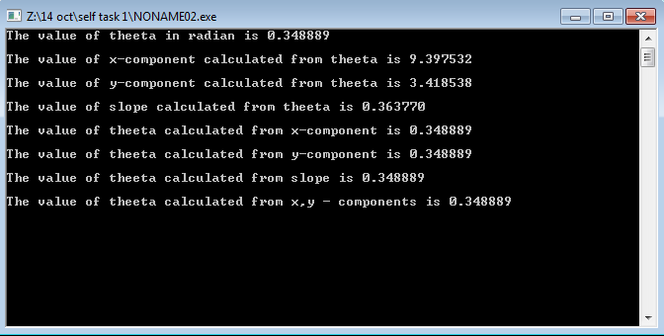

**TASK 3**

**Write a C program to read temperature in centigrade and display a suitable message**

**INPUT**

#include<stdio.h>

int main ()

{

int temperature;

printf("Please enter the temperature in centigrade : ");

scanf("%d",&temperature);

if(temperature<0)

printf("\nThis is freezing weather");

if(temperature>=0&&temperature <10)

printf("\nThis is very cold weather");

if(temperature>=10&&temperature<20)

printf("\nThis is cold weather");

if(temperature>=20 && temperature<30)

printf("\nThis is normal tempreature");

if(temperature>=30 && temperature<40)

printf("\nThe weather is hot");

if(temperature>=40)

printf("\nThe weather is very hot");

getchar();

getchar();

return 0;

}

The screenshot of the above program is:

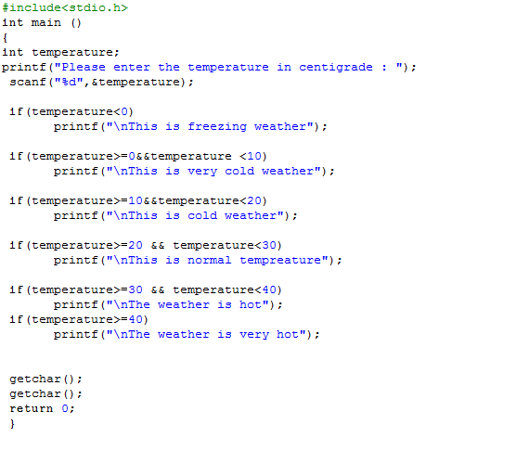

The screenshot of the above program is:

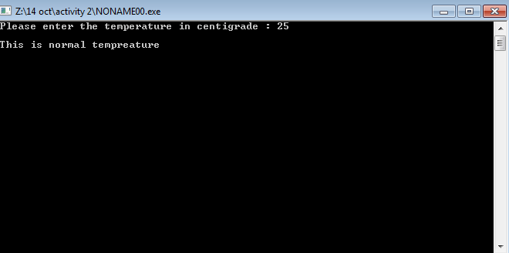

**TASK 4**

**Write a C program to get three integers from user and find the greatest number among three numbers.**

**INPUT**

#include<stdio.h>

int main()

{

int number_1,number_2,number_3;

printf("Plaese enter the number 1, number 2 and number 3 one by one.\n Press enter after entering each number.\n");

scanf("%d%d%d",&number_1,&number_2,&number_3);

if(number_1>number_2&&number_1>number_3)

printf("\nThe greatest number is %d",number_1);

else if(number_2>number_3&&number_2>number_1)

printf("\nThe greatest number is %d",number_2);

else

printf("\nThe greatest number is %d",number_3);

getchar();

getchar();

return 0;

}

The screenshot of the above program is:

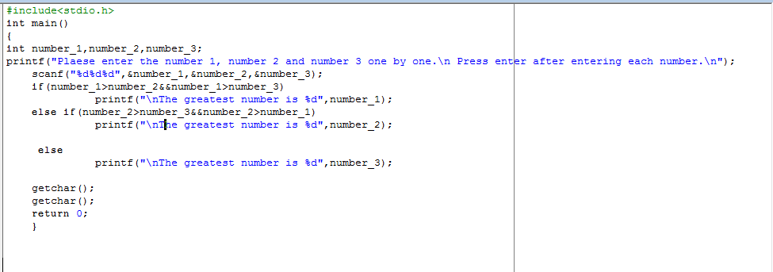

The screenshot of the above program is:

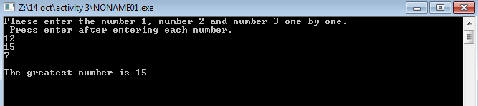

**TASK 5**

**Write a C program to check sign of given number.**

**INPUT**

#include<stdio.h>

int main()

{

int number;

printf("Enter the number here:");

scanf("%d",&number);

if (number<0)

printf("The number is negative");

else

printf("The number is positive");

getchar();

getchar();

return 0;

}

The screenshot of the above program is:

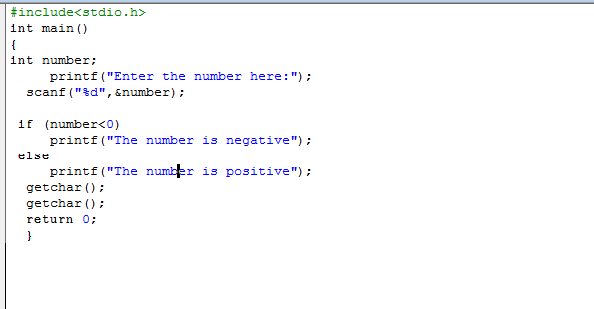

The screenshot of the above program is:

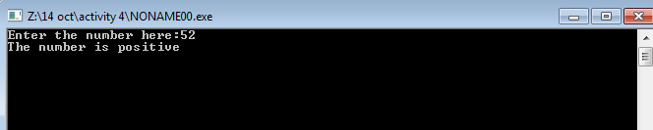

**TASK 6**

**Write a program that lets user enter an integer value between 1 and 10, the program validates the input, if the value entered is between 1 and 10 the program prints the message “Valid Number” and value entered otherwise the program should print message “Invalid Number” and value.**

**INPUT**

#include<stdio.h>

int main ()

{

int number;

printf("Enter the number between 1 and 10 : ");

scanf("%d",&number);

if(number >= 1 && number <= 10)

printf("Valid Number %d",number);

else

printf("Invalid Number %d",number);

getchar();

getchar();

return 0;

}

The screenshot of the above program is:

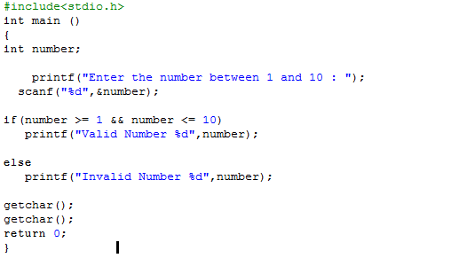

The screenshot of the above program is:

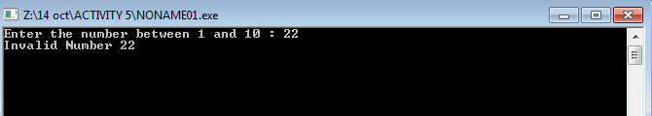

**TASK 7**

**Write a program that ask users to input marks of a subject and print the letter grade**

**INPUT**

#include<stdio.h>

int main()

{

int marks;

printf("Enter your marks of Physics : ");

scanf("%d",&marks);

if(marks>=81 &&marks<=100 )

printf("Grade : A");

else if(marks>=71 &&marks<=80 )

printf("Grade : B");

else if(marks>=61 &&marks<=70 )

printf("Grade : C");

else if(marks>=51 &&marks<=60 )

printf("Grade : D");

else

printf("You have entered Invalid Marks. No grades can be assigned");

getchar();

getchar();

return 0;

}

The screenshot of the above program is:

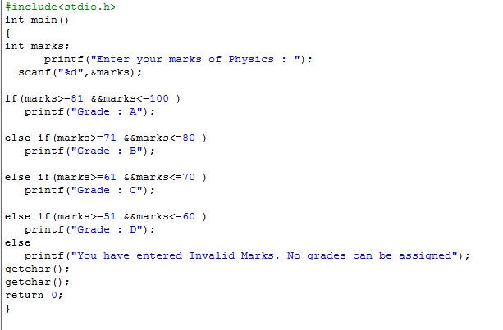

The screenshot of the above program is:

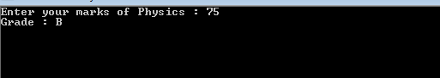

**TASK 8**

**Write a program that gets a three digits integer input and prints the sum of its digits.**

**INPUT**

#include<stdio.h>

int main()

{

int number,quotient,digit_1,digit_2,digit_3,sum_of_digits;

printf("Enter the Number : ");

scanf("%d",&number);

quotient=number/10;

digit_3=number%10;

printf("\nThe 3rd digit is %d.",digit_3);

digit_2=quotient%10;

printf("\nThe 2nd digit is %d.",digit_2);

digit_1=quotient/10;

printf("\nThe 1st digit is %d.",digit_1);

sum_of_digits = digit_1 + digit_2 + digit_3;

printf("\nThe sum of digits is %d.",sum_of_digits);

getchar();

getchar();

return 0;

}

The screenshot of the above program is:

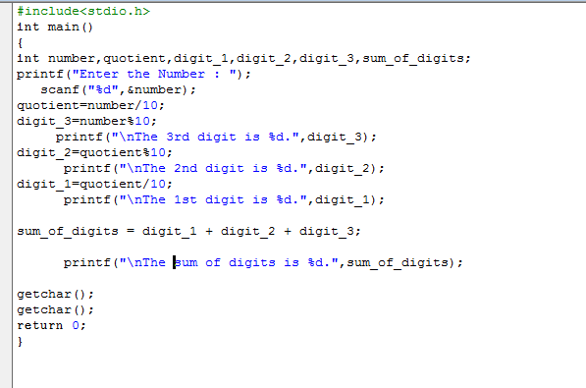

The screenshot of the above program is:

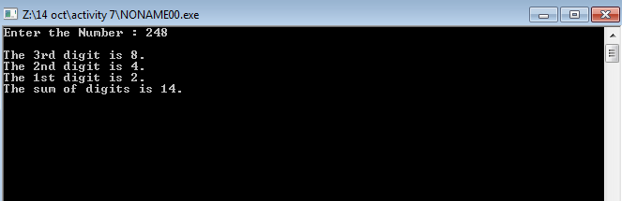

**TASK 9**

**Write a C program to read the age of a candidate and determine whether it is eligible for casting his/her own vote.**

**INPUT**

#include<stdio.h>

int main()

{

int age;

printf("Enter your age:");

scanf("%d",&age);

if(age>=18)

printf("You are eligible for voting");

else

printf("You are not eligible for voting");

getchar();

getchar();

return 0;

}

The screenshot of the above program is:

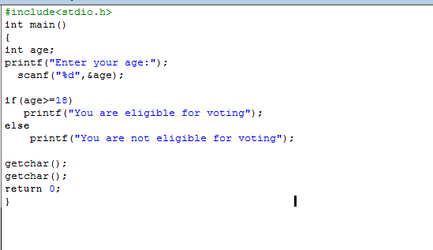

The screenshot of the above program is:

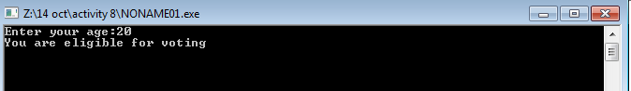

**Task 10**

**Single Condition**

|  |  |
| --- | --- |
| **Statement** |  |
| A and B are equal | A==B |
| A is an even number | A%2==0 |
| 5C is a factor of C | 5C%C==0 |
| B divides C and there is no remainder | B%C==0 |
| C is greater than D | C > D |
| B is an odd number | B%2 != 0 |
| Sum of A and B is less than C | A+C<C |
| C is greater than 100 and less than 200 | C>100 && C<200 |

**Multiple Condition**

|  |  |
| --- | --- |
| **Statement** |  |
| C and D are negative numbers | C<0 && D<0 |
| A is greater than B and C is greater than D | A>B && C>D |
| A is even or B is odd number | A%2==0 && B%2!=0 |
| A or B or C is a positive number | A>0 || B>0 || C>0 |
| A and B are greater than 40 or C and D are less than 10 | A>40 &&B>40 || C<10 &&D<10 |
| A and B are odd numbers | A%2!=0 && B%2!=0 |
| A and C is negative and D is positive | A<0 && C<0 && D>0 |
| A or B is odd and C is even | A%2!=0 || B%2!=0 &&C%2==0 |

**Home tasks**

**Home task -1**

**Write a program that gets a three digit number from the user and checks whether the number is an Armstrong number or not.**

**Input**

#include<stdio.h>

#include<math.h>

int main()

{

int number,dig_1,dig_2,dig_3,quotient,sum_of_cubes;

printf("This program checks whether a number is Armstrong Number or not.\n");

printf("Enter the Number you want to check: ");

scanf("%d",&number);

quotient=number/10;

dig_1=number%10;

dig_2=quotient%10;

dig_3=quotient/10;

sum_of_cubes=pow(dig_1,3)+pow(dig_2,3)+pow(dig_3,3);

if(sum_of_cubes==number)

printf("The entered number is an Armstrong Number.\n");

else

printf("The entered number is not an Armstrong Number.\n");

printf("Press any key to continue.....");

getchar();

getchar();

getchar();

return 0;

}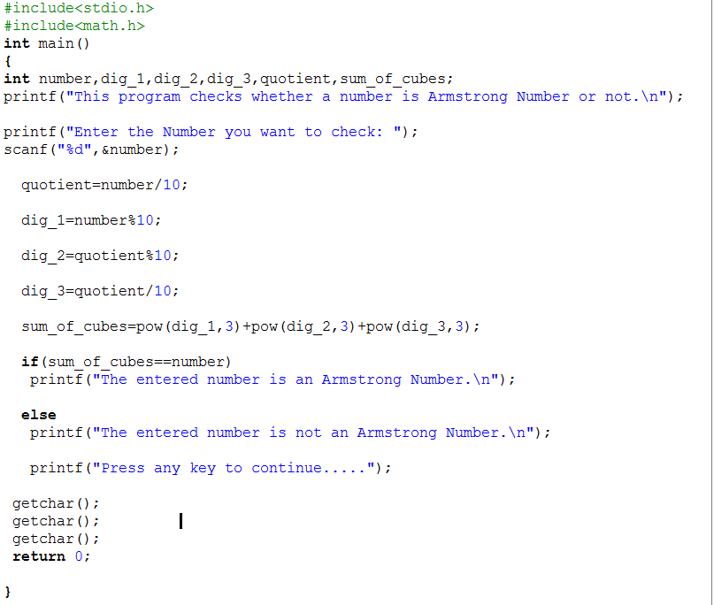

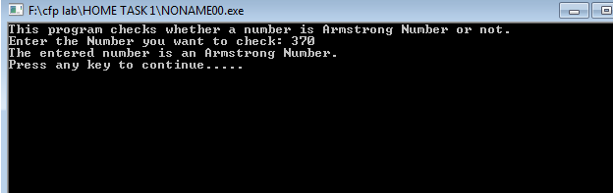

**Home Task 2**

**Write a program that ask user to a character and check whether a character is an alphabet or not.**

**Input**

#include<stdio.h>

int main()

{

char a;

printf("Please enter the character :");

scanf("%c",&a);

if(a>='a' && a<='z'||a>='A'&&a<='Z')

printf("The charcater is an Alphabet.");

else

printf("The character is not an Alphabet.");

getchar();

getchar();

return 0;

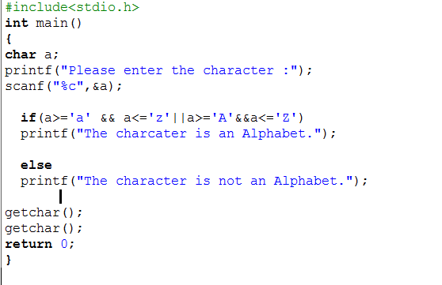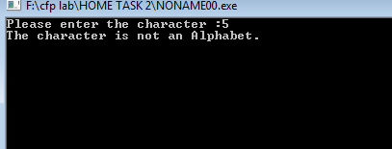

**Home Task 3**

**Write a program that ask user to a character and check whether a character vowel or consonant.**

**Input**

#include<stdio.h>

int main()

{

char a;

printf("Please enter the character :");

scanf("%c",&a);

if(a=='a'||a=='A'||a=='e'||a=='E'||a=='i'||a=='I'||a=='o'||a=='O'||a=='u'||a=='U')

printf("The charcater is a Vowel.");

else if(a>='a' && a<='z'||a>='A'&&a<='Z')

printf("The charcater is a Consonant.");

else

printf("The character is not an Alphabet.");

getchar();

getchar();

return 0;

}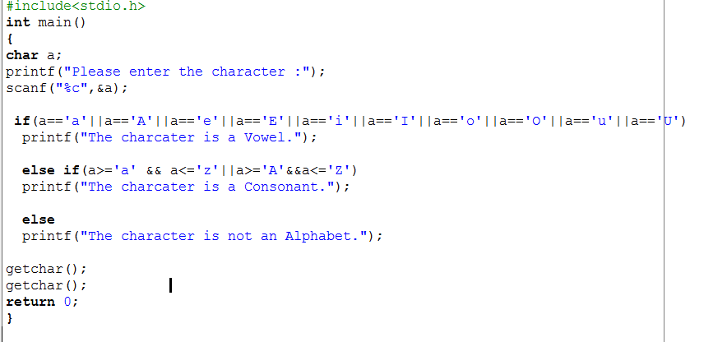

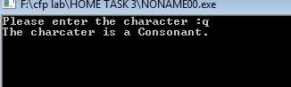

**Home Task 4**

**Write a program t to check whether the triangle is valid or not if sides are given.**

**Input**

#include<stdio.h>

int main()

{

int a,b,c;

printf("Enter 1st side of the triangle: ");

scanf("%d",&a);

printf("Enter 2nd side of the triangle: ");

scanf("%d",&b);

printf("Enter 3rd side of the triangle: ");

scanf("%d",&c);

if(a+b>c && a+c>b && b+c>a)

printf("The triangle is VALID.");

else

printf("The triangle is INVALID.");

getchar();

getchar();

getchar();

return 0;

}

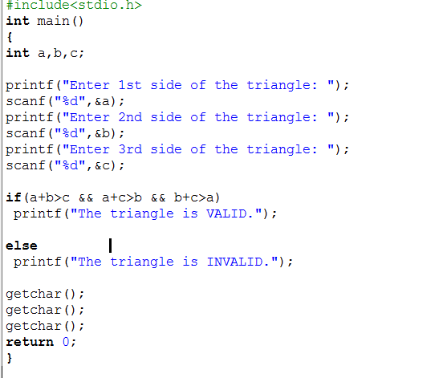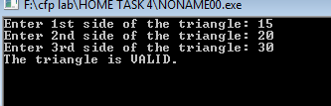

**Home Task 5**

**Write a program in C to calculate and print the Electricity bill of a given customer. The customer id and unit consumed by the user should be taken from the keyboard and display the total amount to pay to the customer.**

**Input**

#include<stdio.h>

int main()

{

int units_consumed,ID;

float rate,surcharge,bill,total_bill;

printf("Here you can calculate your Total Electricity Bill.\n");

printf("Enter your customer ID : ");

scanf("%d",&ID);

printf("\n Units Consumed : ");

scanf("%d",&units_consumed);

if(units_consumed<=199.0)

rate=1.20;

else if(units_consumed>=200.0&&units_consumed<400.0)

rate=1.50;

else if(units_consumed>=400.0&&units_consumed<600.0)

rate=1.80;

else

rate=2.00;

bill=rate*units_consumed;

if(bill<400)

surcharge=0;

else

surcharge=bill*15.0/100;

total_bill= bill+surcharge;

if(total_bill<100)

total_bill=100;

printf("\n Customer IN No : %d",ID);

printf("\n Units Consumed : %d",units_consumed);

printf("\n Amount charges @Rs. %f per unit : %f",rate,bill);

printf("\n Surcharge Amount : %f",surcharge);

printf("\n Net Amount Paid by the Customer : %f",total_bill);

getchar();

getchar();

getchar();

getchar();

return 0;

}

